Daniel Morris
ddm855
11188831

Unfortunately, due to my error my data collected for assignment 2 got mixed with my data used for assignment 1. I had to remake my C355A12-1.txt, C355A12-2.txt, and C355A12-6.txt files to accommodate for this. Just to be on the safe side I have included all of my assignment 1 files with their changes with this submission.

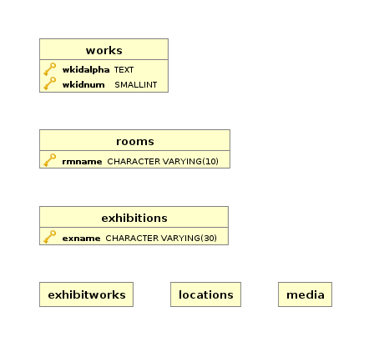
1.
a)

Using the feedback from my assignment 1 I realized that I did not relate any of my tables to each other. I fixed this by making sure that everything that uses values that are also used in another table actually references that table. A problem I came across was referencing two attributes at once. (The ones that made up the primary key for works) I fixed this my creating a new constraint and foreign key and using that to reference the two attributes of works.
I also did not have enough tables in my assignment 1. Originally I had 6 tables as part of my assignment. I now realize that I need a table for doors and that I need a table for exhibition locations so that if an exhibition wants to be in two rooms it can be. I added these two tables and removed the now redundant attributes from my other tables.

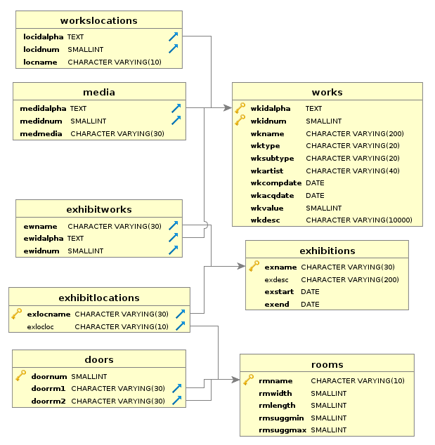

b)
To create three new exhibitions, I manually made psql commands to insert the new exhibitions into their corresponding tables. I calculated the necessary dates for these exhibitions in these commands. I also manually entered the exhibit locations of the new exhibits. I added the exhibit works using a tab delimited text file since it would not make sense to add this much data manually.
To accomplish the task of keeping track of where the works are at all times I decided to add a column in the works locations stating when the location of the work was changed. This column I set default to 2016-07-01 to resemble the start of this database representing the museum. I decided to make this temporal data closed-open so that if no future exhibitions are planned then the database manager will not have to worry about an end date for when a work will be in it’s location. To add all the necessary rows into the worksLocations table I used two insert statements.
The first insert statement was used to put all of the works that are/will be in exhibitions into storage 1 day after the exhibition ends.
The second insert statement was used to pre-program all of the works that will be a part of the 3 new exhibitions added previously. Since all of the works form the assignment 1 are already in their exhibits I decided to obsolete those in this statement.
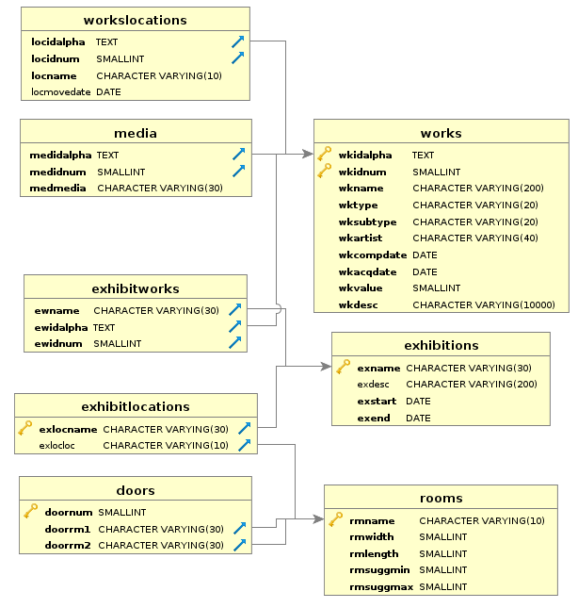
2.
a)
I first added two columns to my works table to accommodate the need to hold a borrowed status (either “Owned”, “Borrowed”, or “Potentially Borrowed”) and a column for who the works are borrowed by. If the works are owned this column is left as NULL. I set all of the works in the museum to owned before adding the new borrowed works.
To add the new works into the database I created two tab delimited files. One file containing the new works info and and their borrowed info, and the other containing each works media information.

To add to the worksLocation table I created a temporary table from the first tab delimited file containing the new works info. I used this table to select certain attributes from it and check if the work is borrowed so that I know it will actually be in storage. I then inserted these works into the workLocations table with ‘Storage’ set as the location. I will not save the location of the possibly borrowed works since their location will not be in my museum.

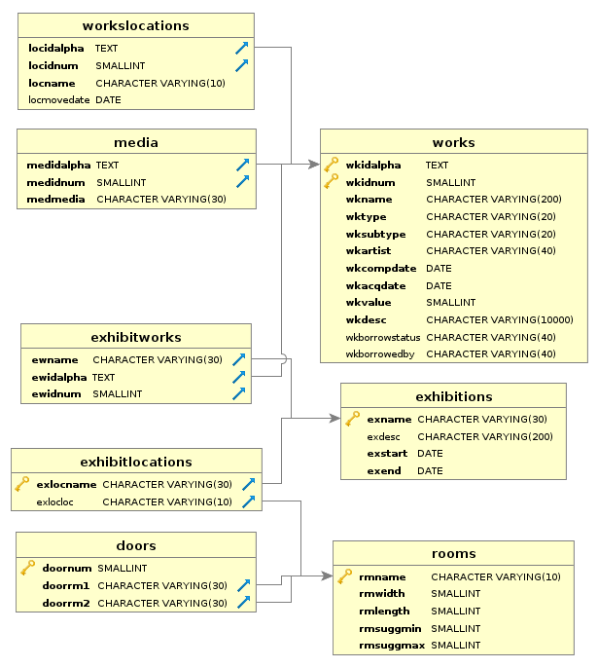

b)
To accomidate the functionality of being able to see when each room will be available I decided to add a column to the rooms table. This column is labelled availabilityDate to symbolize when the room will be available for use. I set the default value of this to July 1st 2016. I then added the new gallery to the rooms table and set its availability date to todays date + 2 months. I then added a row to the doors table to symbolize the connection between the new gallery D and gallery B.

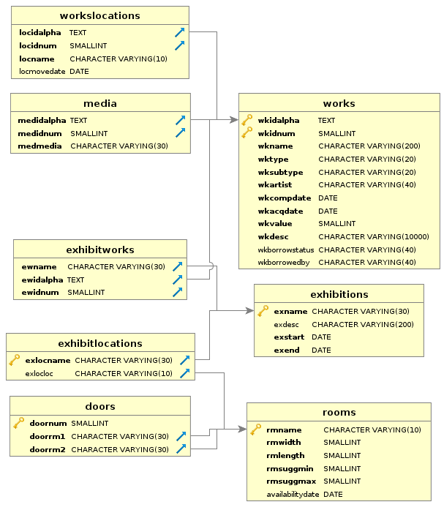

c)
To start off I added select statements for querying the database for how often a word shows up in the descriptions of the works.
Upon analysis of the number of words that show up in the work’s descriptions I noticed that a fair amount of the works have the word “Aboriginal” in them. I used this knowledge to add another column in the works table that was called “wkIsAboriginal” with a default value of “No”. I then created a table of all the id’s of the works that contain the word “aboriginal” in their description by searching through all of the work’s descriptions for the keyword. I used this table to update the works in the work table so that they have “Yes” in the wkIsAbroiginal column.

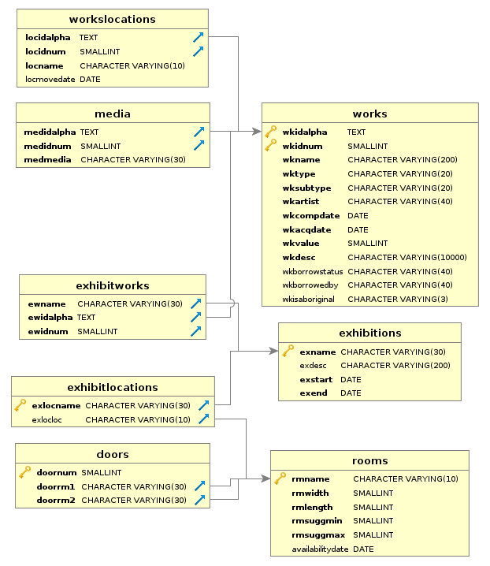

3.
1a – selecting the two tables that I forgot to add into assignment one that are now added

1b –
Selecting the exhibitions table to show that the new exhibitions were added. Noticing that their start date is exactly 5 days after the end date of the exhibit that was previously in that room.
Selecting the exhibitworks table to show that the new exhibit works have been successfully added to their exhibits.
Selecting the worksLocations table to show that the works in the new exhibit have been successfully moved to that room.

2a-
Selecting new and identifying attributes from the works table to make sure that the new works have been added and that their borrowing status’ are accurate

2b-
Selecting the room name and availability date from the room table to make sure that the new room was added with the correct availability date and the other rooms have their availability date set to July 1st.
Selecting all the columns from the doors table to make sure a new door was added going from gallery B to gallery D.

2c-
Selecting the identifying attributes, the aboriginal classification, and the description from the work’s table to make sure the aboriginal classification correctly matches the work’s description.

